President Janos Ader
Office of the President of the Republic
Sándor-Palace,
1536 Budapest, Pf. 227
Hungary
e-mail to the presiden’st office: sajto@keh.hu
February 19, 2018
Subject: Dr. Agnes Géreb
Dear Mr. President Ader,
We, the undersigned, are respectfully writing to express our deep concern at the latest judgment (January 9, 2018) in the case of Dr. Agnes Gereb.
As representatives of 16 organizations acting under the umbrella of ENCA throughout Europe, we wish to convey to you why we hold Dr. Gereb in such esteem, and why we are so very concerned about the legal actions that have been taken against her.
The European Network of Childbirth Associations (ENCA) was launched in 1993 in Frankfurt, Germany on the initiative of the German partners “GfG” which stands for “Society for Childbirth Education.” ENCA is a network of organizations campaigning for improvements in perinatal care for mothers and babies. The consumer activists, parents, and childbirth educators who join ENCA, recognize the necessity of developing strategies to improve conditions in pregnancy, birth and for the postpartum period throughout Europe. Dr. Gereb was active in the launching of ENCA, which is based on the World Health Organization (WHO) 1986 publication “Recommendations on the Appropriate Use of Technology for Birth.” Despite this, there has been a standardization of obstetric and midwifery care in Europe based exclusively on the medical view point, without taking the individual unique situation into account. Consequently women centered care and midwifery practice has been marginalized limiting the freedom of choice and additional options, disadvantaging mothers and babies.
Dr. Gereb has worked tirelessly to improve the treatment and care of women in Hungary, and has encouraged the medical and midwifery professions to update their practices to the benefit of women and babies, and the Hungarian health care system.

The following are some of her many innovative achievements over four decades of providing care:
- Dr. Gereb worked for 17 years in hospital as an obstetrician-gynecologist, and in 1977 was the first who enabled fathers to be present at births. This is now standard practice.
- Her work influenced her fellow medical colleagues at the neonatal unit to allow newborn babies to stay with their mothers. This is now standard practice.
- In the eighties, Dr. Gereb obtained a new degree in psychology so that she could work in the area of obstetrics and psychology. Today there is a psychologist in most hospitals’ obstetrics departments.
- In 1992, she organized the first international conference in Szeged on undisturbed birth – attended by 300 delegates including Hungarian obstetricians and hospital midwives.
- Dr. Gereb created the Alternatal Foundation, where she continued her educational work through conferences, books, and films, and beyond that she has provided prenatal classes for some 10,000 parents dealing with hospital birth.
- She assisted the arrival of 3,500 healthy homebirth babies, and has encouraged many families to take the homebirth route, and in doing so has provided additional quality care that complements the Hungarian health care system.
With regard to the right for fair and balanced treatment of Dr. Gereb in this court case regarding adverse birth incidents, we ask that you consider the following:
- Adverse events do happen, and when they do, they must be judged fairly whether they take place at home or in hospital. This has not occurred in Dr. Gereb's case.
- In comparison to hospital maternity doctors, she has been treated in an unfair and discriminatory way, because had these same adverse outcomes happened in hospital, they would never have been referred to a criminal court.
- She was unfairly singled out for prosecution for birth incidents which would have had the same outcomes in hospital.
- The allegations made against her were not supported by scientific evidence, as the hospital court experts failed to act objectively since they had a pre-disposition against homebirth.
- Many Hungarian hospital doctors who have had similar outcomes have not been investigated, let alone prosecuted. It is concerning that the same standards of judgment in those cases were not applied to Dr. Gereb’s case.

Dr. Gereb has worked tirelessly to improve maternity care in Hungary. She is an exemplary citizen, a dedicated professional, and an internationally respected midwife and doctor. We believe that excessive punishment is not the way forward, and hope that reconciliation and rehabilitation would be considered as a key to a positive resolution.
Securing Dr. Gereb’s personal and professional freedom would allow her to find her new place in Hungarian midwifery services, and allow her to continue to contribute her experience and innovative ideas to the further improvement of maternity services in Hungary, and internationally.
Because professionals in this field all over Europe and further abroad look to Hungary, we respectfully ask that you consider helping in this complicated and long-running case.
Most sincerely and with our best regards,

Elisabeth Geisel, ENCA coordinator, GfG hon. Chair
and the following organizations:


Bosnia- Hercegowina: HNO Center Fenix


Bulgaria: Association “Estestveno”




Czeck Republic: Association APERIO Společnost pro zdravé rodičovství, h.a.m.
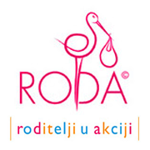

Croatia: Roda



France : CIANE collectif interassociatif autour de la naissance

Germany: Gesellschaft für Geburtsvorbereitung - Familienbildung und Frauengesundheit- Bundesverband e.V. , Greenbirth


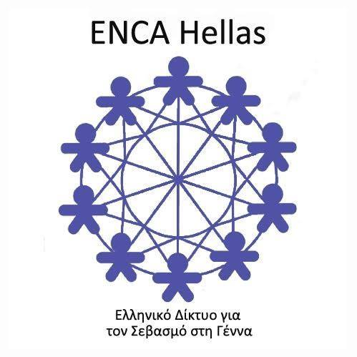

Greece: ENCA Hellas


Italy: Associazione Innecesareo

The Netherlands: www.enca-nederland.nl



Portugal: Associação Portuguesa pelos Direitos da Mulher na Gravidez e Parto



Poland: Fundación Rodzic po Ludzku, “Childbirth with Dignity”


Rumania: Mama Pentry Mame




Slovakia: Slovenské duly (Doula organisation)

Spain: Asociación El Parto es Nuestro


Turkey: Istambul Birth Academy



United Kingdom: AIMS Association for Improvements in the Maternity Services

